SOCIAL + DIGITAL ASSETS
Client AHCCCS
Project Phase II Social + Digital Assets
Date September 30, 2026

Audience: Members
Channels It Will Live On: To be incorporated into AHCCCS’ organic social content calendar, run as paid social advertising, and be available for download via the Partner portal for distribution via their own channels such as social, on websites, email, etc. (option for co-branding if requested).
Languages: English & Spanish
Target Launch Date: 10/8/26
Objective of Assets: Messaging moves from general awareness of upcoming changes to helping members understand who may be impacted or exempt and directing them to KeepMyAHCCCS.com for the most up-to-date information and tools so they can be prepared to take action.
An expanded library gives partners fresh content to share throughout the preparedness phase rather than repeatedly using the same post. Messaging will rotate across key topics including who may be impacted, exemptions, upcoming actions and where to find current information to maintain awareness, reinforce understanding and reduce creative fatigue.

1. STANDALONE
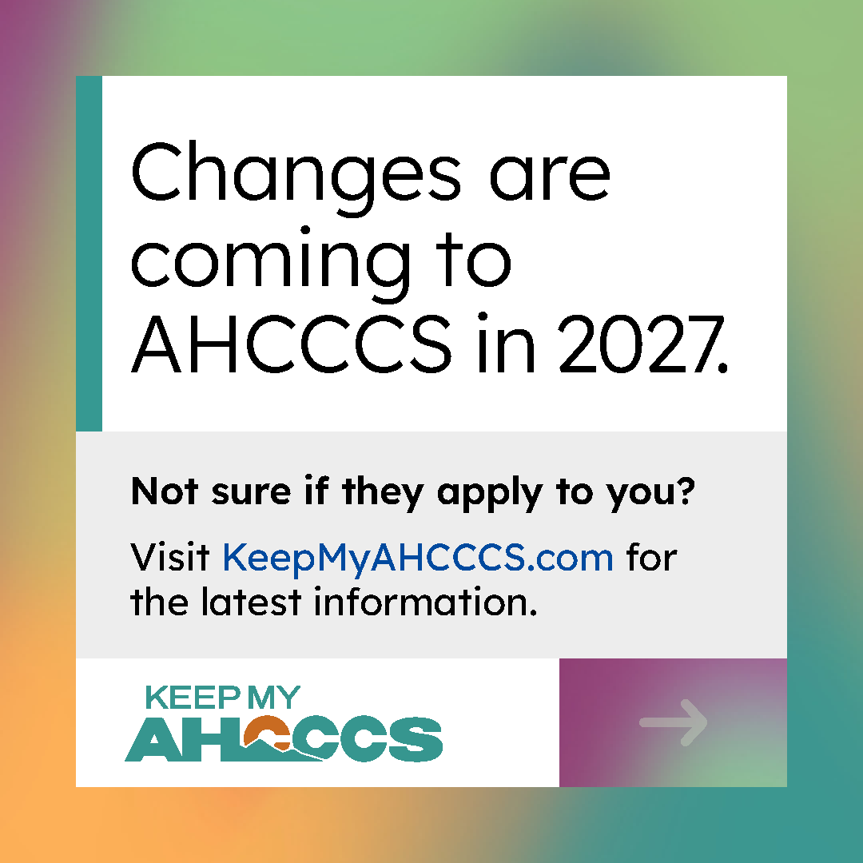
Caption
Some adults ages 19-64 may see changes to their AHCCCS coverage starting in 2027. This may include new work requirements and more frequent renewals.
What applies to you depends on your situation. Find out more and get the latest information at KeepMyAHCCCS.com.

2. STANDALONE
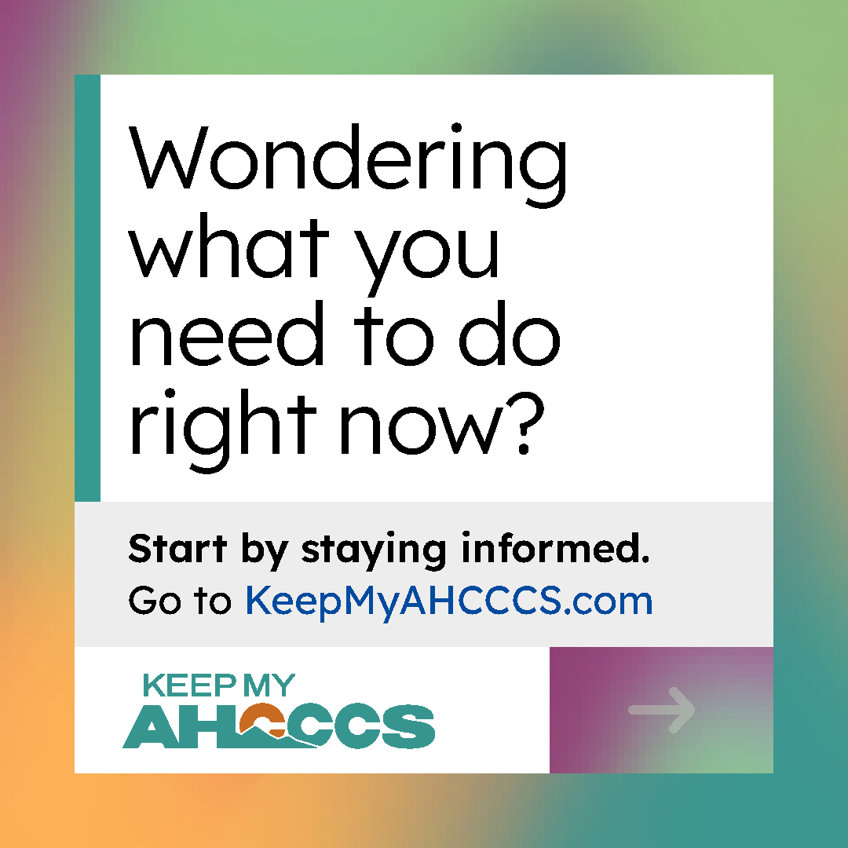
Caption
You may have questions about upcoming changes to AHCCCS. AHCCCS will let you know if the changes apply to you and what steps you may need to take.
Right now, you can make sure your contact information is up to date and visit KeepMyAHCCCS.com for the latest updates.

3. CAROUSEL
Slide 1
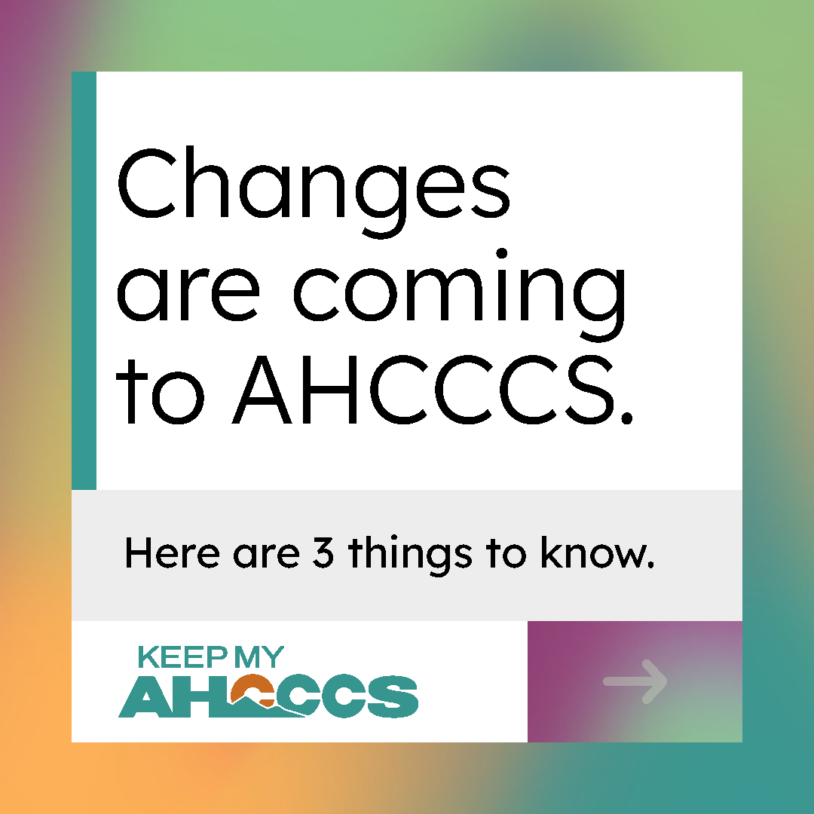
Slide 2
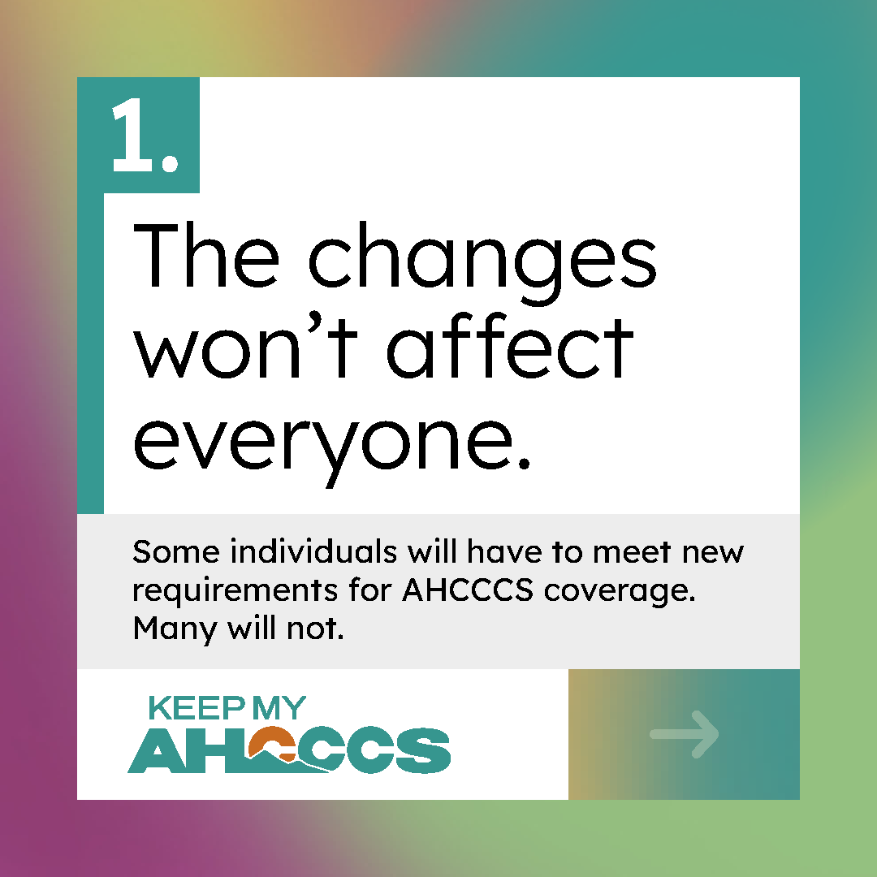

Slide 3
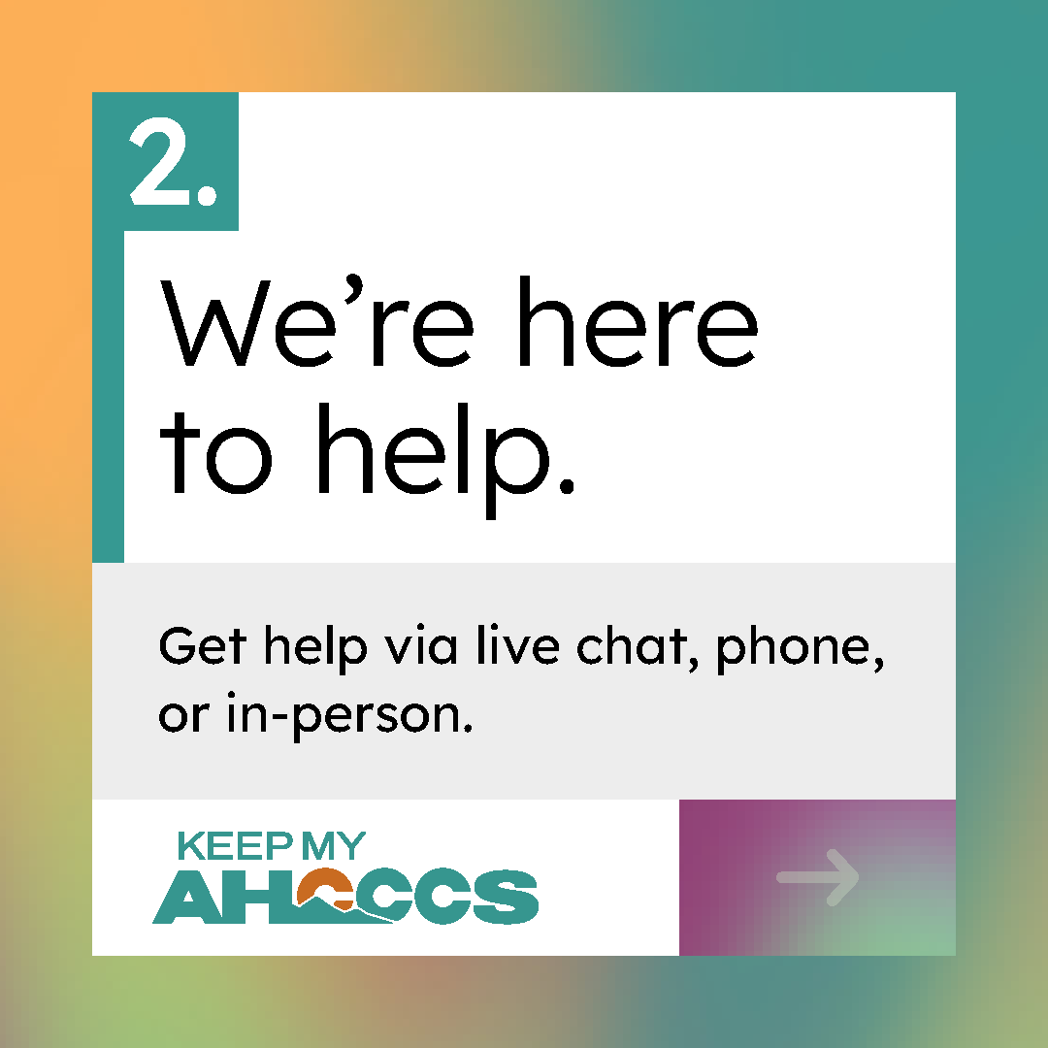
Slide 4
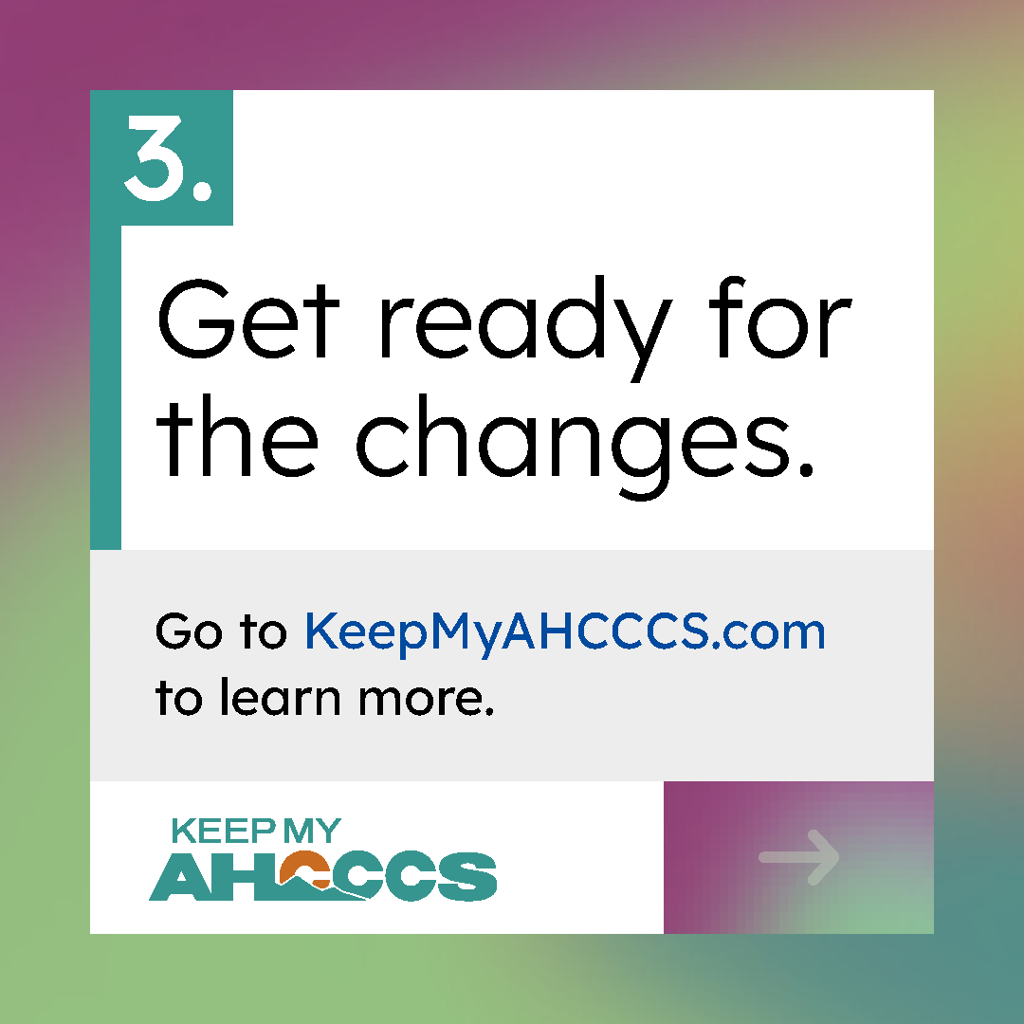
Caption
There’s a lot of information about upcoming AHCCCS changes. For current information, visit KeepMyAHCCCS.com.

4. STANDALONE
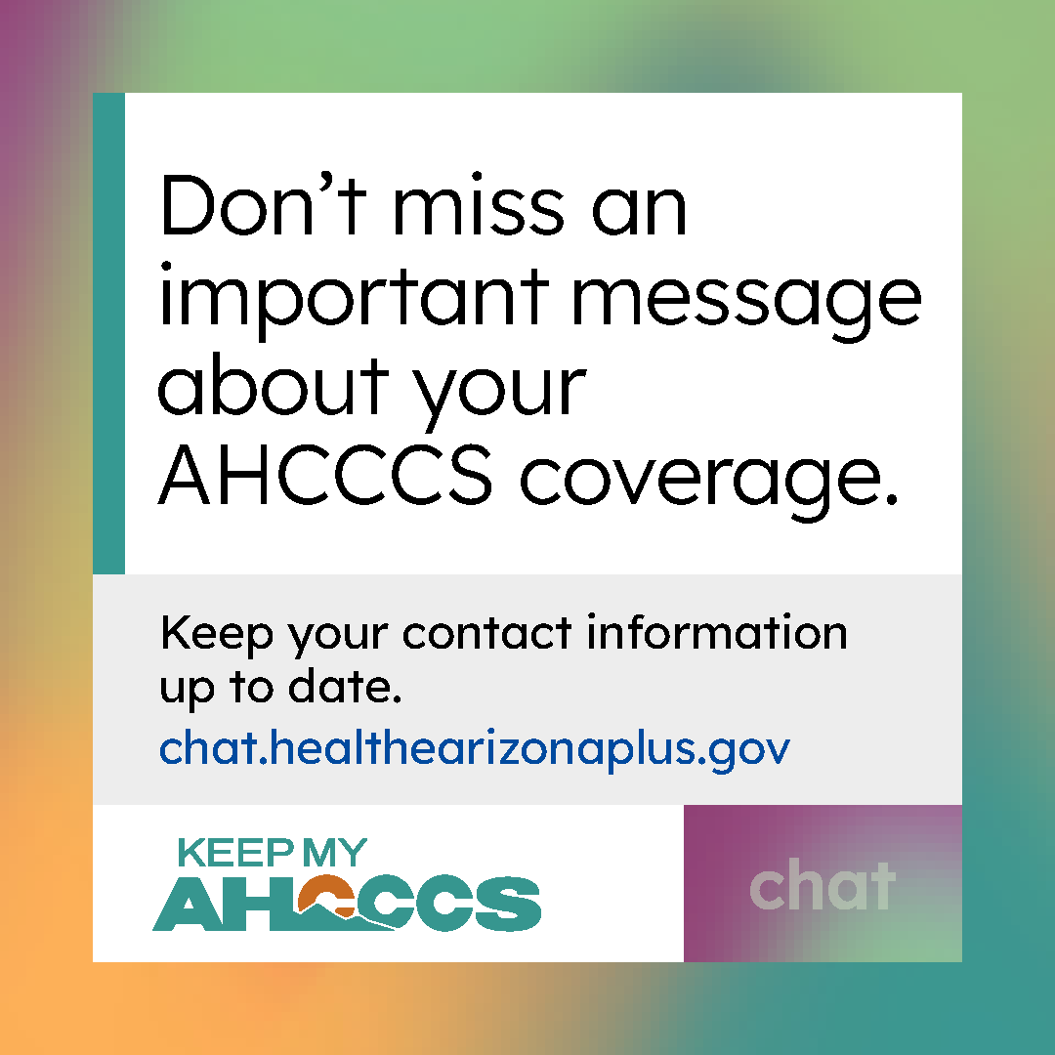
Caption
Your address, phone number, and email help AHCCCS reach you with important information about your coverage. Update your contract information via live chat @ chat.healthearizonaplus.gov.
You can also visit KeepMyAHCCCS.com for more information.

5. CAROUSEL
Slide 1
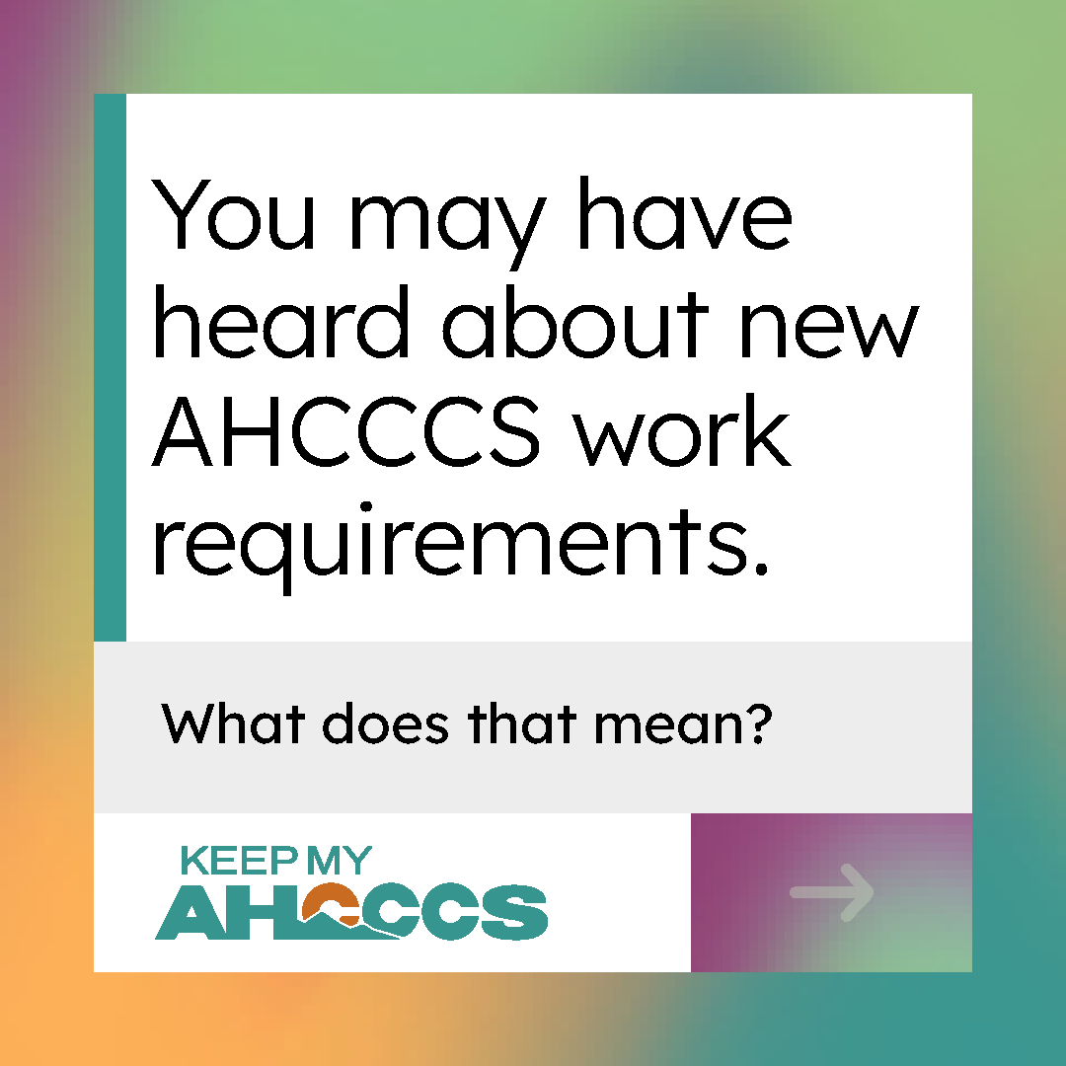
Slide 2
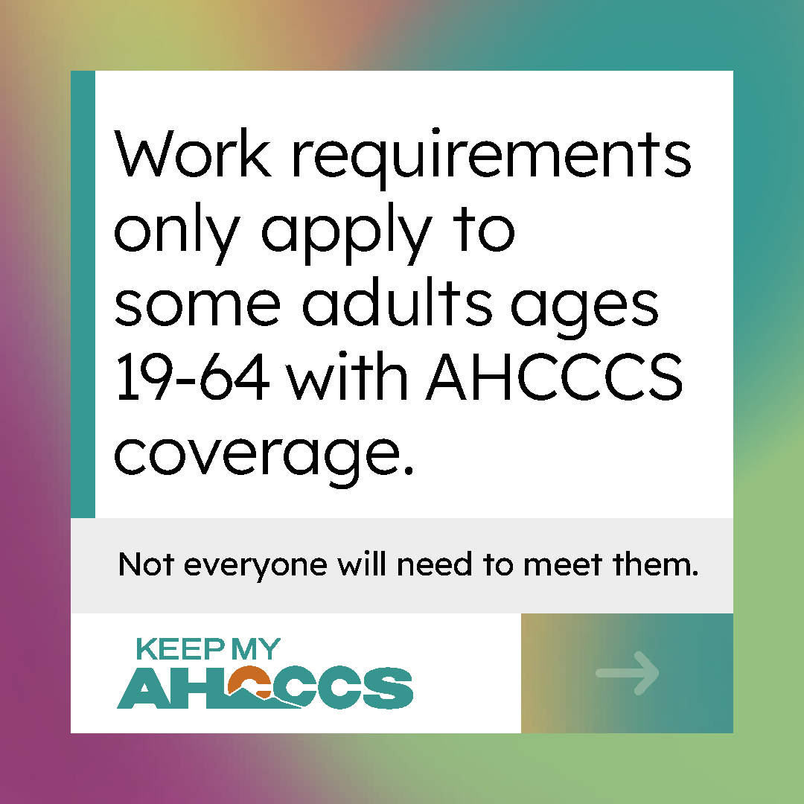
Slide 3
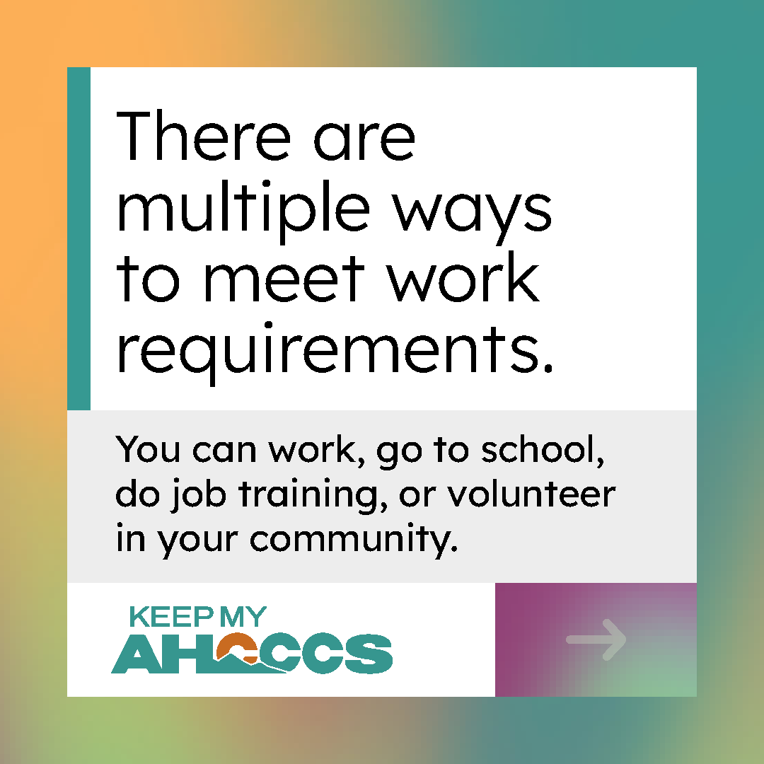
Slide 4
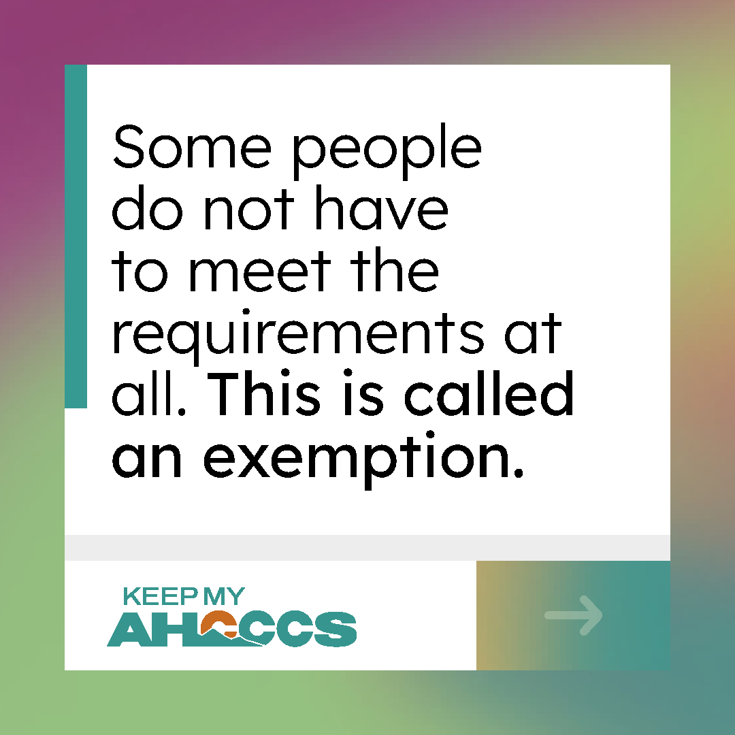
Slide 5
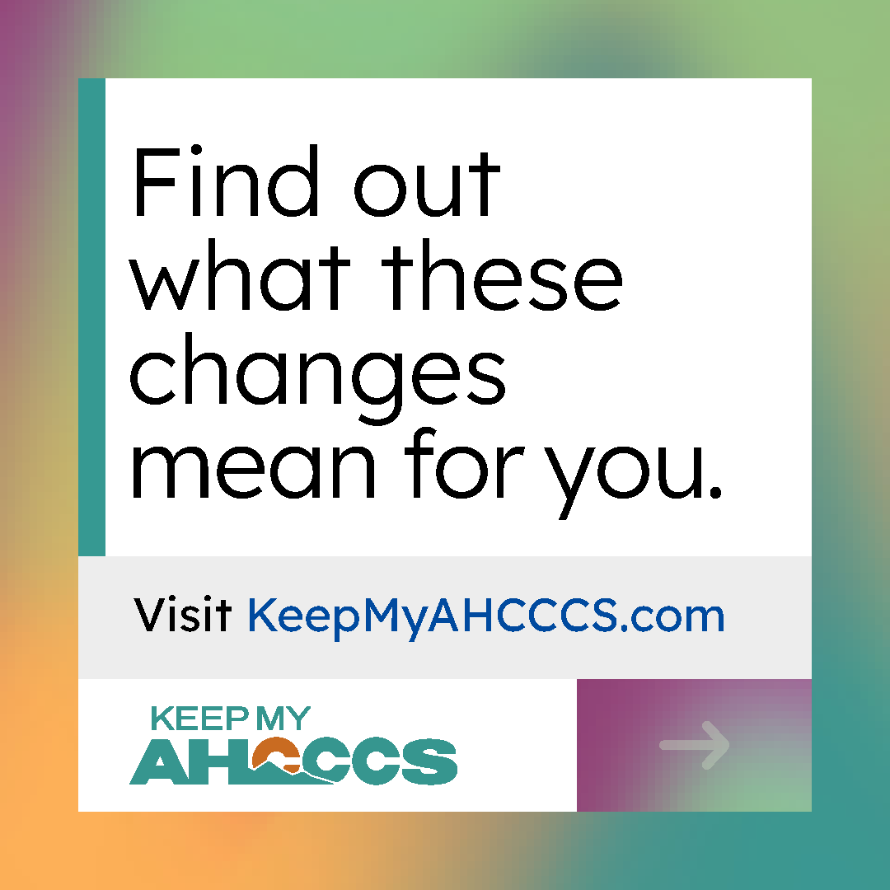
Caption
New work requirements are coming for some adults with AHCCCS in 2027.
Learn more at KeepMyAHCCCS.com.

6. STANDALONE
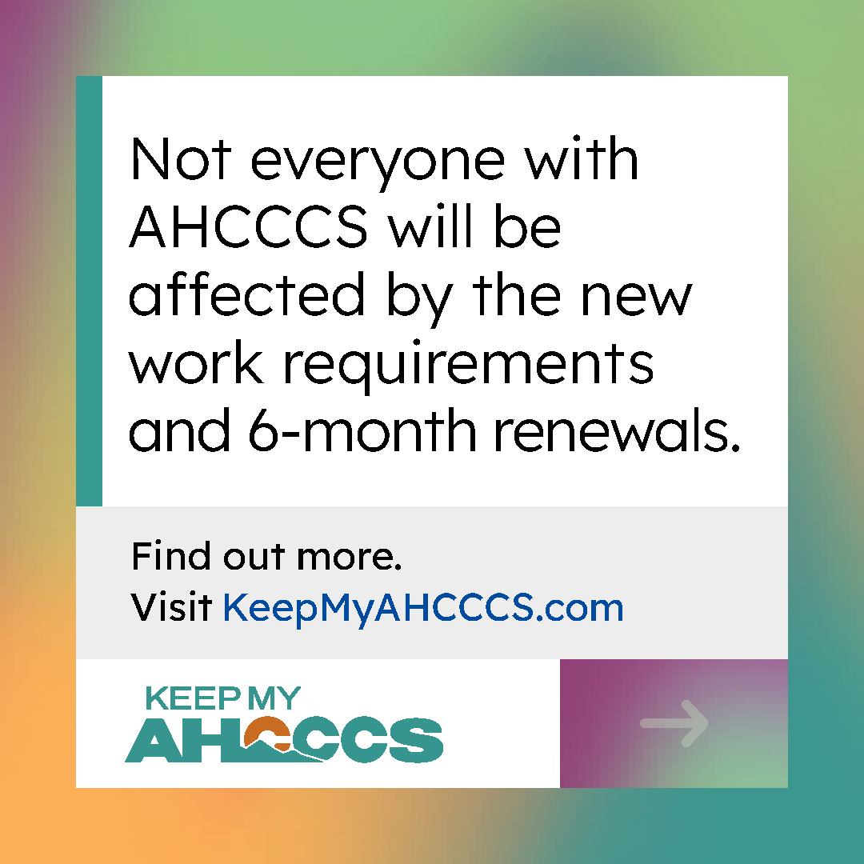
Caption
Upcoming changes to AHCCCS work requirements and renewals only apply to certain individuals.
To find out more, visit KeepMyAHCCCS.com.

7. CAROUSEL
Slide 1
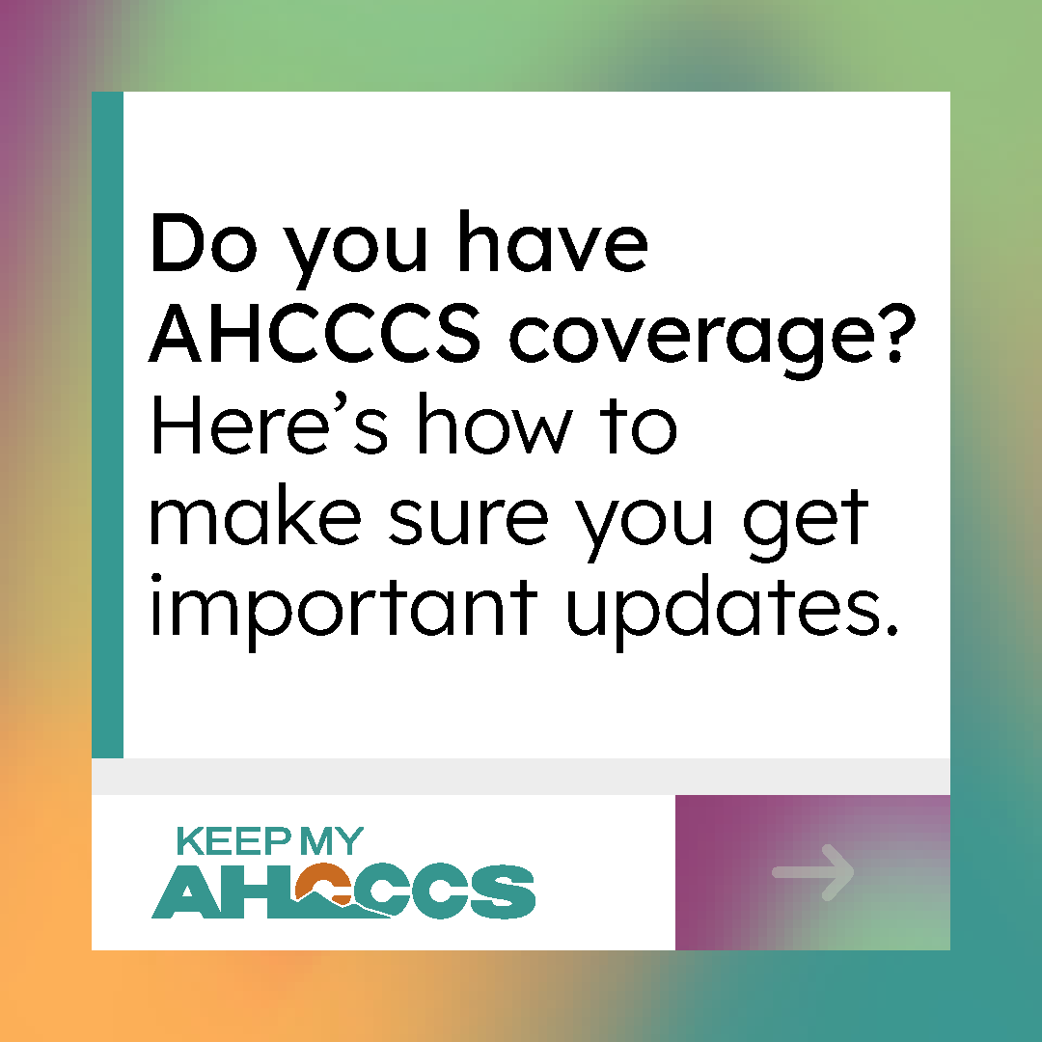
Slide 2
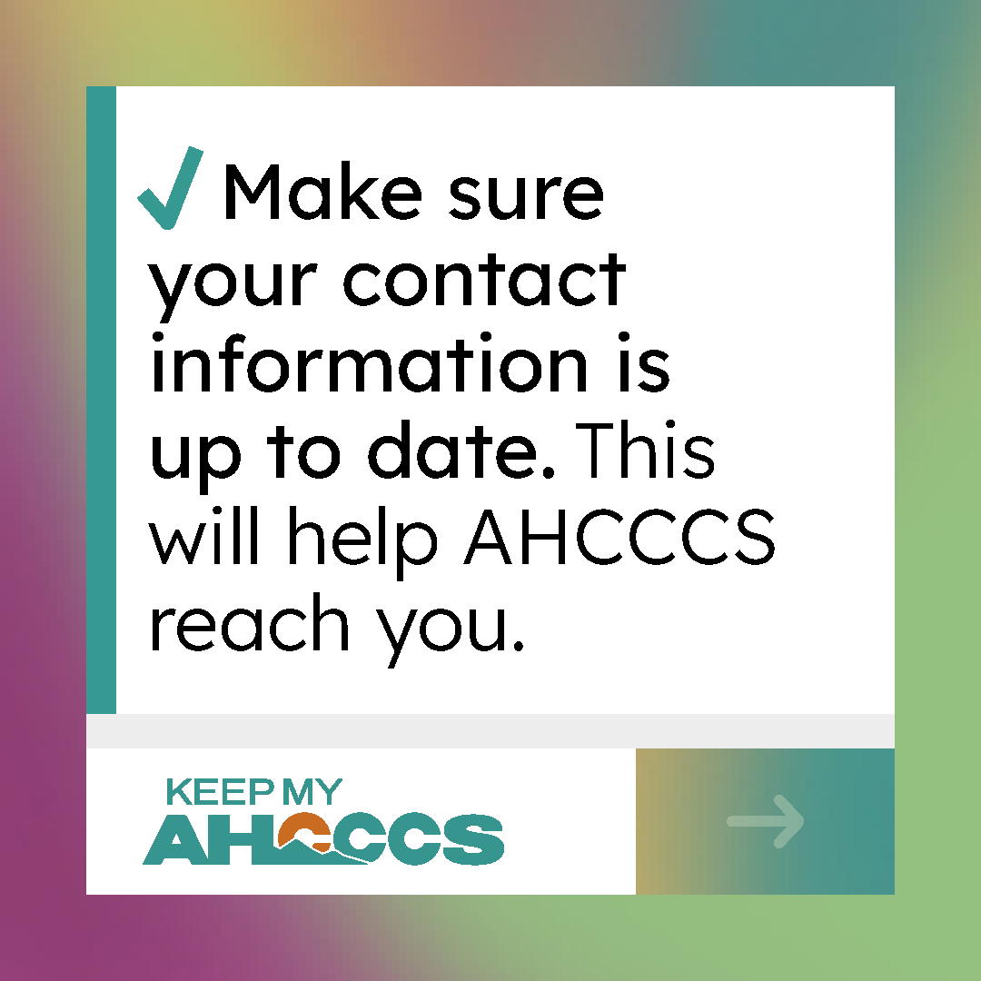
Slide 3
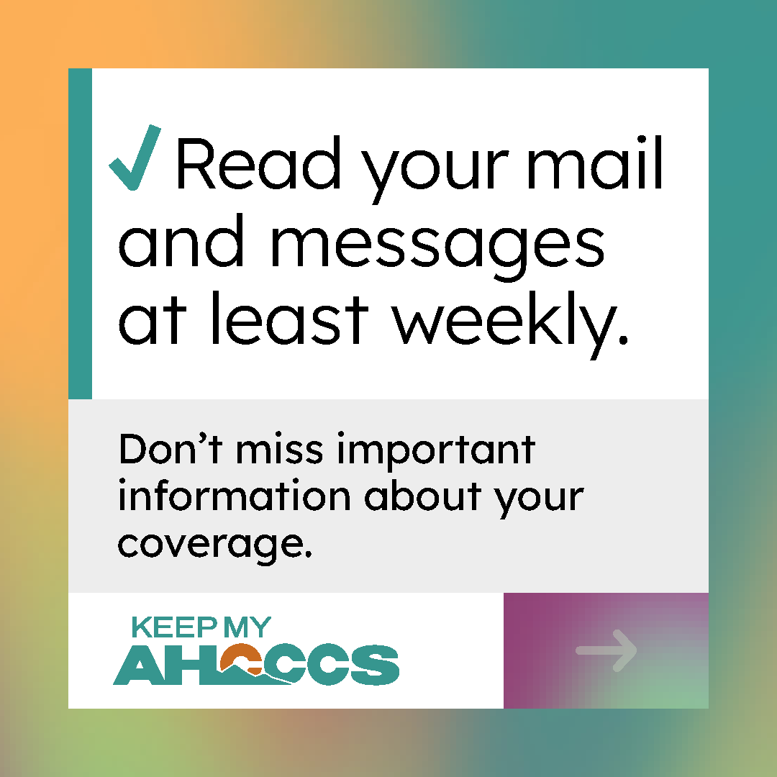
Slide 4
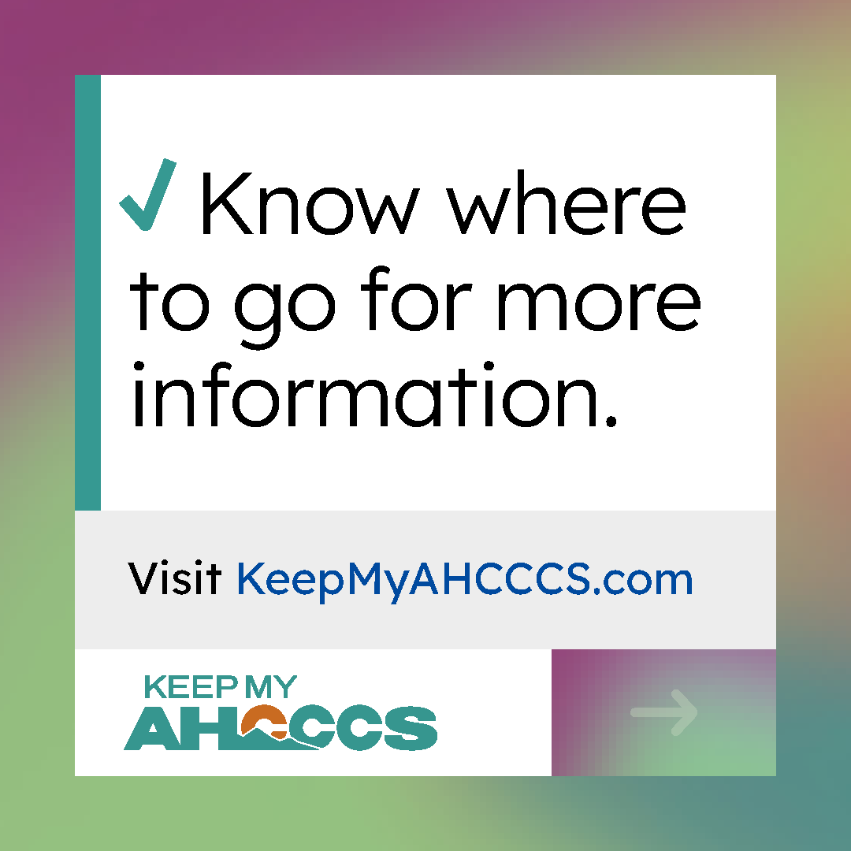
Caption
There's a few simple steps to stay prepared for upcoming AHCCCS changes:
1) Keep your contact information up to date.
2) Read important messages about your coverage.
3) Know where to find information.
Check KeepMyAHCCCS.com for the latest updates and resources.

